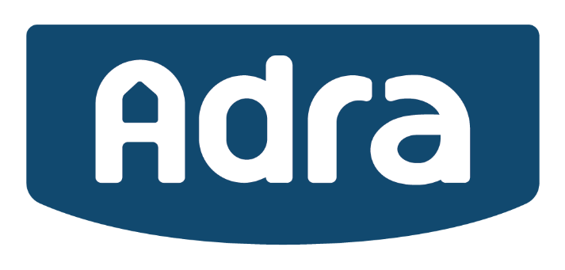
Cais am brofiad gwaith / Application for work experience
Enw:
Name:

Cyfeiriad:
Address:

Rhif ffôn:
Phone number:

Cyfeiriad ebost:
Email address:

Statws: (Disgybl ysgol, disgybl coleg/prifysgol, oedolyn mewn addysg)
Status: (School pupil, university/college student, adult learner)
Enw a chyfeiriad o’r ysgol, coleg neu prifysgol:
Name & address of your school, college, or university:
Manylion eich cwrs:
Details of your course:

Dyddiad geni:
Date of birth:

Pa fath o waith hoffech wneud yn ystod eich profiad gwaith?
What kind of work would you like to do during your placement?
Enw cyswllt brys:
Emergency contact name:

Rhif ffôn cyswllt brys:
Emergency contact phone number:

A ydych chi’n adnabod neu yn perthyn i unrhyw gyfarwyddwr, aelod o’r Bwrdd neu weithiwr yn Adra? Os ydych, rhowch fanylion
Are you known or related to any Director, Board member or employee of Adra? If yes, please give details
DEDDF AILSEFYDLU TROSEDDWYR 1974 / REHABILITATION OF OFFENDERS ACT 1974
Rhowch fanylion unrhyw euogfarnau neu gyhuddiadau dan ystyriaeth o bob trosedd (neu droseddau honedig) gan gynnwys troseddau gyrru. Os ydych yn datgelu trosedd sydd wedi darfod, caiff ei hanwybyddu
Please give details below of any convictions or charges outstanding (or alleged offences) including driving offences. If you inadvertently disclose a conviction, which is regarded as spent, it will be ignored.
Rhowch wybod i ni pam hoffech brofiad gwaith hefo Adra, a be yda chi isho gael allan o’r profiad. Rhowch unrhyw wybodaeth pellach yma i gefnogi eich cais.
Please tell us why you would like a placement with Adra, and what you hope to gain from the experience. Please add any additional details in support of your application.
Pa ddyddiadau hoffech wneud y profiad gwaith:  On what dates you would like to undertake work experience: | …../…..../…….. i/to …../…..../……

SGILIAU IAITH CYMRAEG (1:Gwael Iawn 2:Gwael 3:Da 4:Da Iawn 5:Ardderchog - Ticiwch y bocsys)
WELSH LANGUAGE SKILLS (1:Very Poor 2: Poor 3:Good 4: Very Good 5: Excellent – Tick the boxes)
 | Lefel/Level 1 | Lefel/Level 2 | Lefel/Level 3 | Lefel/Level 4 | Lefel/Level 5
Siarad Anffurfiol
Speaking Informally
Siarad Ffurfiol
Speaking Formally
Ysgrifennu
Writing

Dim sgiliau Iaith Cymraeg (ticiwch os yn berthnasol)
No Welsh Language skills (please tick if appropriate):

Yr wyf yn datgan, hyd y gwyddwn i, fod yr wybodaeth ’rwyf wedi ei rhoi wrth wneud y cais yn gywir. Rwyf yn deall fod unrhyw gynnig o brofiad gwaith yn ddibynnol ar gywirdeb y wybodaeth hon. Dylier nodi os gwelwch yn dda nad ydym yn cydnabod derbyn y ffurflenni yma. Byddwn yn ysgrifennu atoch os byddwch yn llwyddiannus yn cyrraedd rhestr fer ar gyfer cyfweliad.

I declare that, to the best of my knowledge and belief, the information I have given in applying for work experience is true and accurate. I understand that any offer of work experience is conditional upon the accuracy of this information. Please be advised that we do not acknowledge receipt of these forms. We will write to you only if successful in being short-listed for interview.

Llofnod/Signature: Dyddiad/Date
Plîs ebostwich y ffurflen hon i recriwtio@adra.co.uk, neu postiwch i Adnoddau Dynol, Ty Coch, Llys y Dderwen, Parc Menai, Bangor, Gwynedd, LL57 4BL
Please email your completed form to recriwtio@adra.co.uk, or alternatively post to Human Resources Department, Ty Coch, Llys y Dderwen, Parc Menai, Bangor, Gwynedd, LL57 4BL

Os ydych eisiau mwy o wybodaeth am Adra, cerwch at ein wefan www.adra.co.uk
If you would like further information about Adra please visit our web site at www.adra.co.uk

